Readme: This project is licensed under the terms of the MIT license.

Video: [C++ 3D Game Tutorial 3: Creating 3D Engine - Swap Chain](https://www.youtube.com/watch?v=8ZsAR4j2S9g&list=PLv8DnRaQOs5-ST_VDqgbbMRtzMtpK36Hy&index=3)

Author: Parcode

**3. Creating the SwapChain**

1)

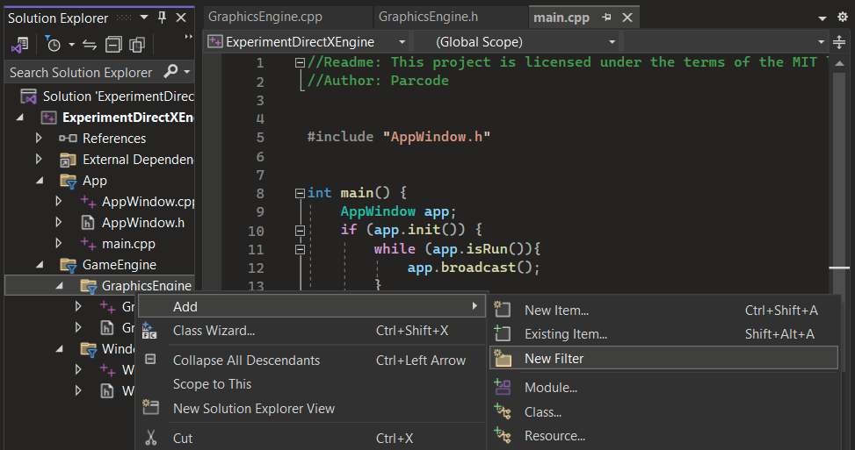

1. Create a folder named **SwapChain** in **GraphicsEngine**

2)

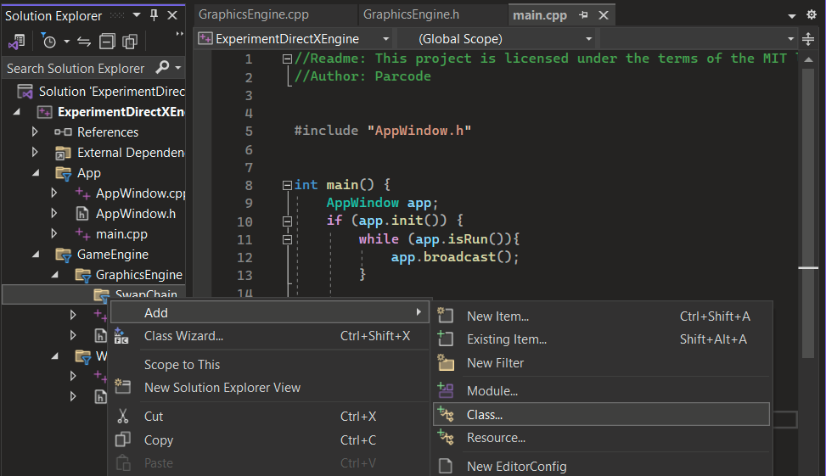

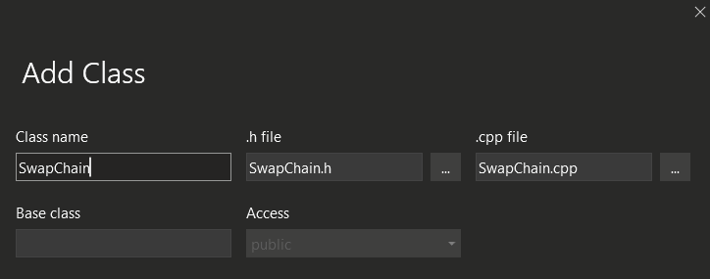

1. Move SwapChain.h and Swapchain.cpp to **SwapChain** folder

3)

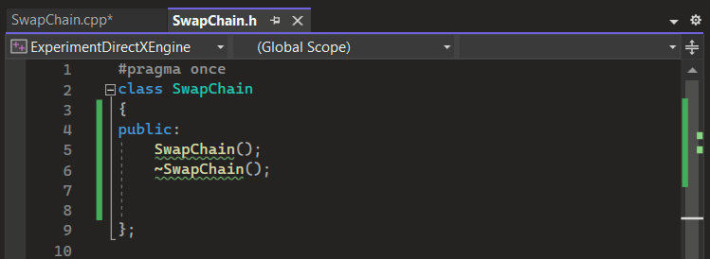

4)

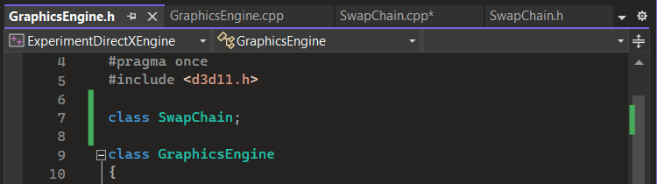

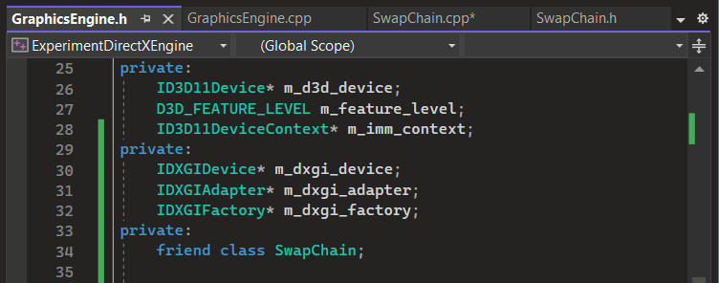

1. **IDXGIDevice** - for rendering graphics and managing rendering resources
2. **IDXGIAdapter** - queries information about the the GPU's capabilities
3. **IDXGIFactory** - allows DXGI objects to be created and managed
4. **friend** - declared function or class can access private or protected members

5)

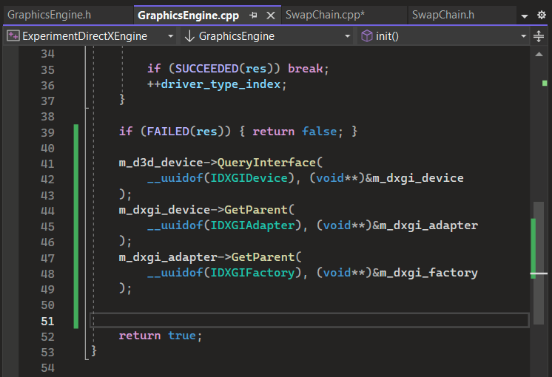

1. **__uuidof** - returns a universally unique identifier
2. **\*\*** - accesses the origin of the value
3. **&** - gets the memory address

6)

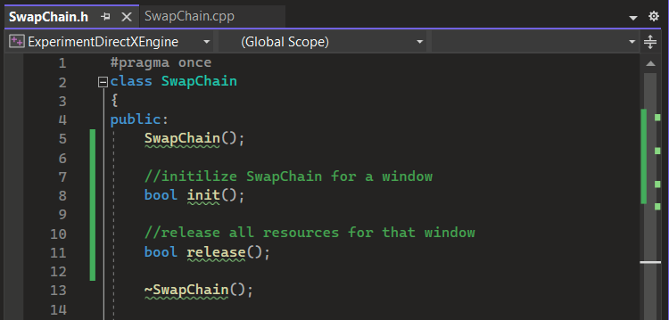

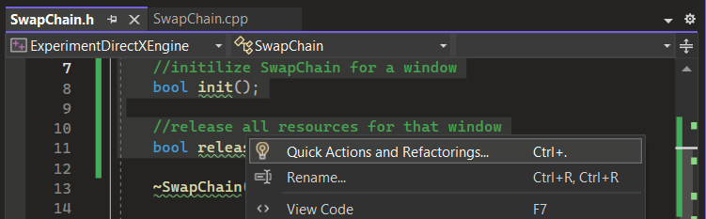

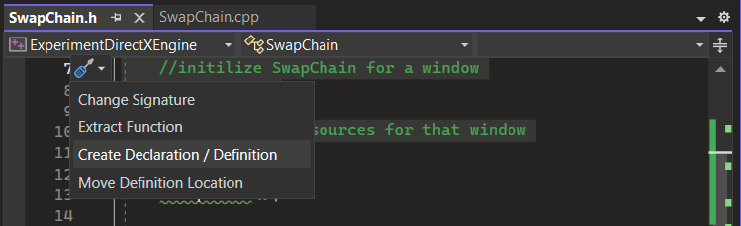

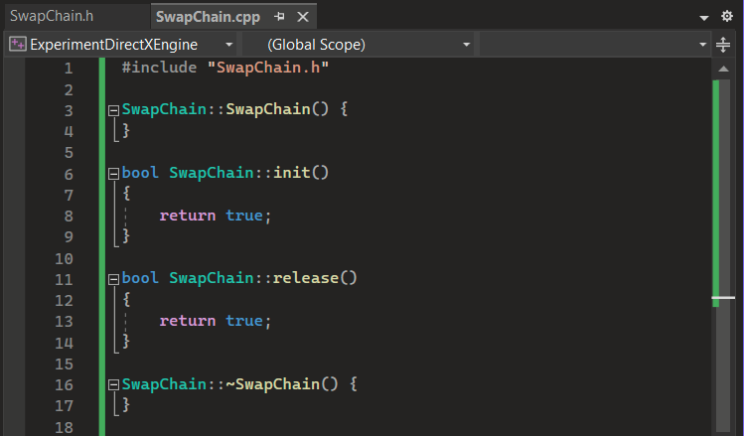

7)

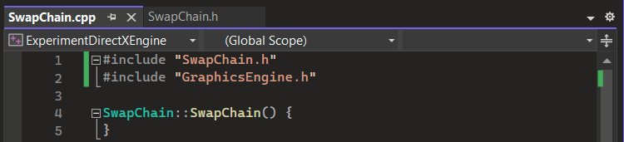

8)

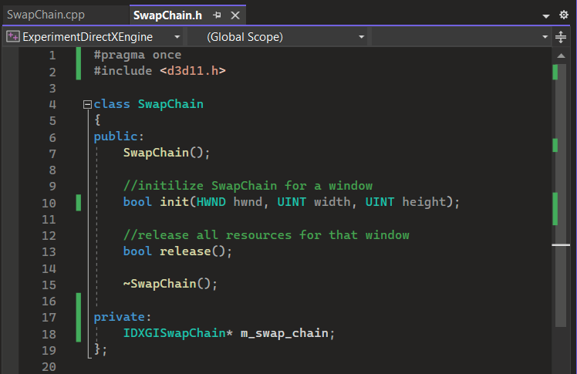

1. **IDXGISwapChain** -

9)

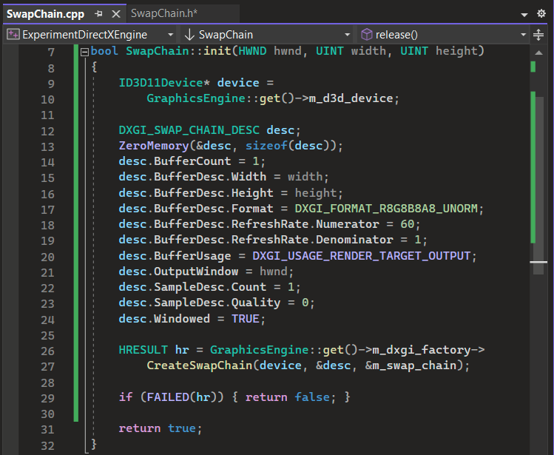

1. **ZeroMemory** - clear the memory by setting it to 0
2. **DXGI_SWAP_CHAIN_DESC** -
   1. **BufferCount** - Specifies the number of back buffers in the swap chain
   2. **BufferDesc** - back buffer's properties, such as its format, width, and height
      1. **Width** - width in pixels of the back buffer
      2. **Height** - height in pixels of the back buffer
      3. **Format** - defines how color information is stored for each pixel
      4. **RefreshRate** -
         * **Numerator** - the number of refreshes per second
         * **Denominator** - the amount of times numerator reaches max
   3. **BufferUsage** - purposes back buffer for rendering or presenting
   4. **OutputWindow** - window where graphics will be presented
   5. **SampleDesc** - specifies the multi-sampling settings
      1. **Count** - how many points are used for each pixel
      2. **Quality** - the quality level for multi-sampling or anti-aliasing
   6. **Windowed** - boolean for fullscreen or not
3. **CreateSwapChain** - creates a swap chain to manage graphics on window
4. **DXGI_FORMAT_R8G8B8A8_UNORM** - common pixel format RGBA
5. **DXGI_USAGE_RENDER_TARGET_OUTPUT** - uses resources as a render target

10)

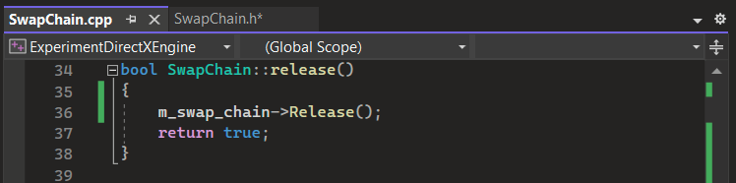

11)

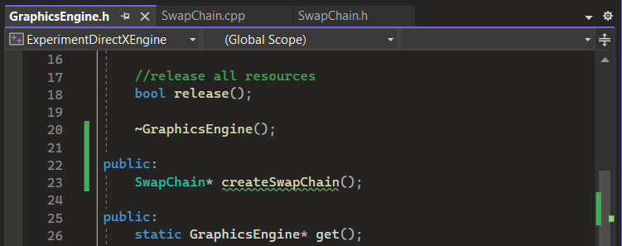

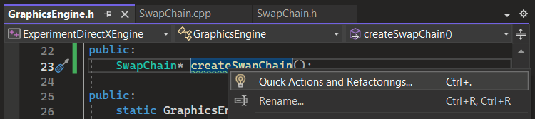

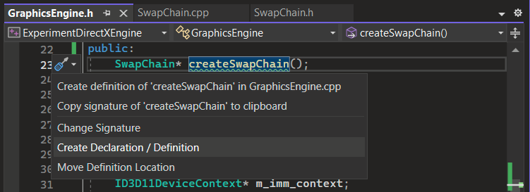

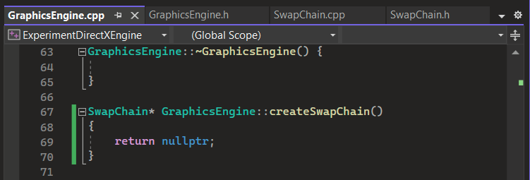

12)

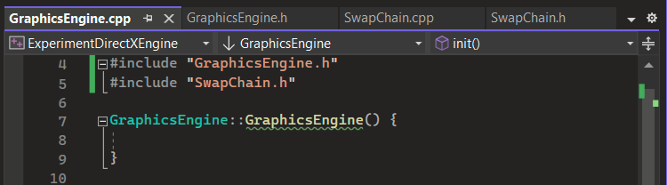

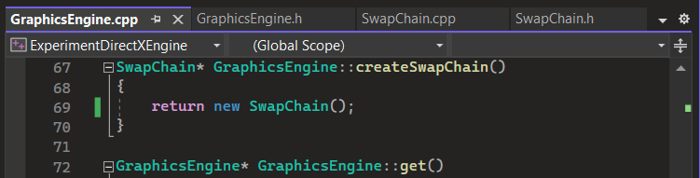

13)

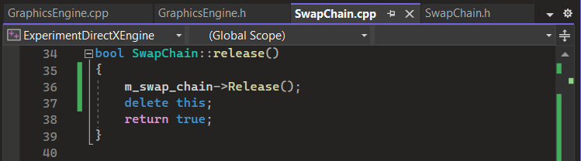

1. **delete** - used to deallocate that memory and calls the destructor for objects.

14)

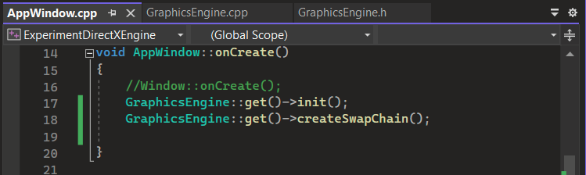

15)

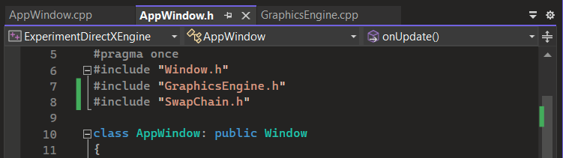

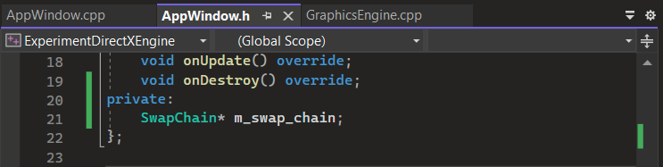

16)

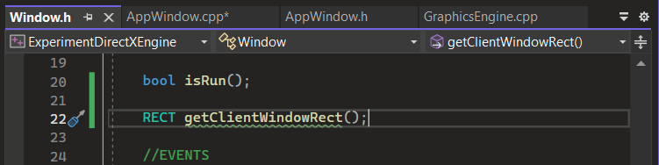

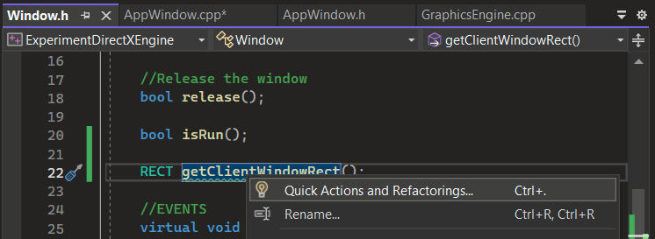

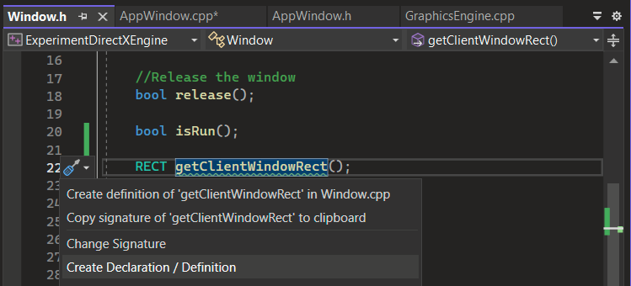

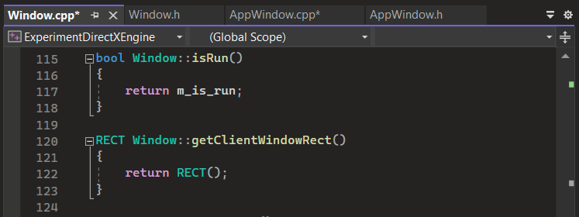

1. **RECT** - defines the position and dimensions of a rectangular 2D area.

17)

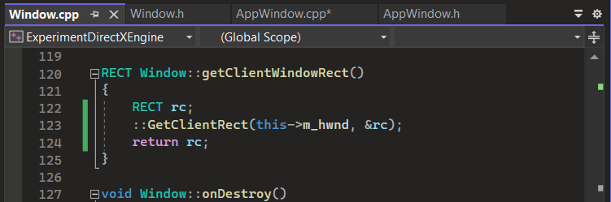

18)

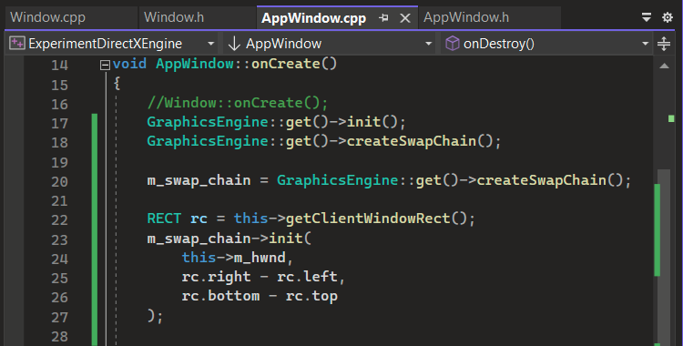

19)

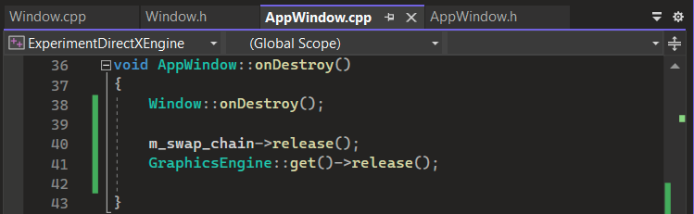

20)

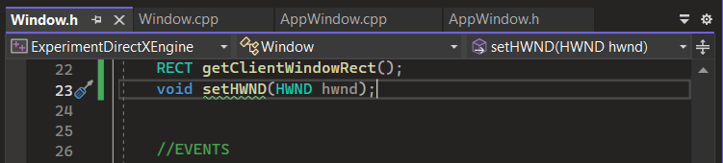

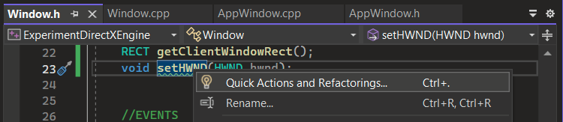

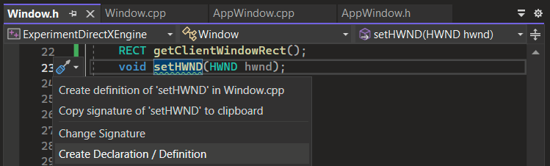

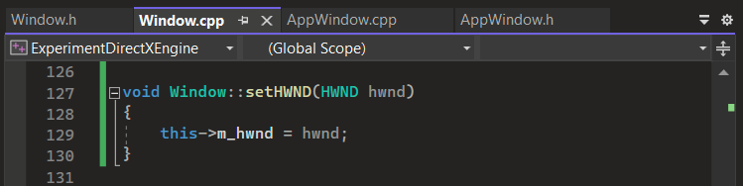

21)

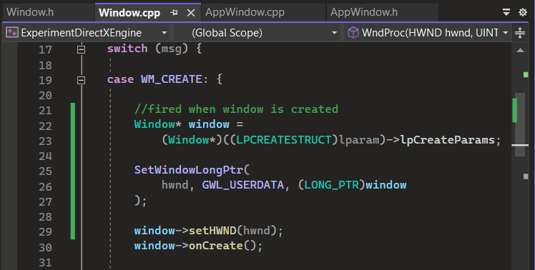

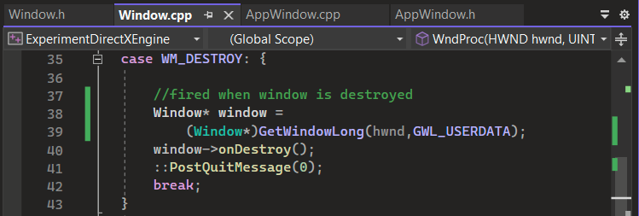

1. **LPCREATESTRUCT** - accesses information about creating or modifying windows
2. **GWL_USERDATA** - accesses or sets user-specific data associated with a window
3. **GetWindowLong** - retrieves long integer values associated with a window

22)

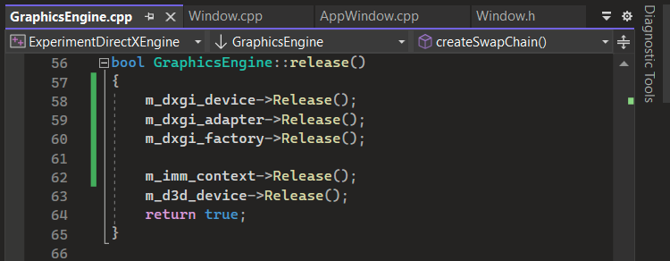

23)

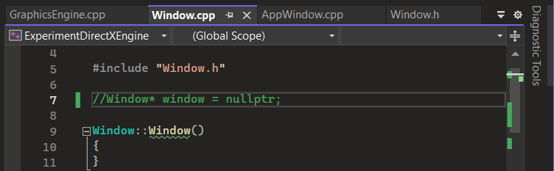

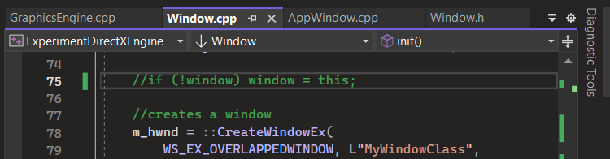

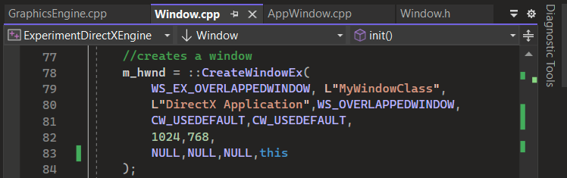

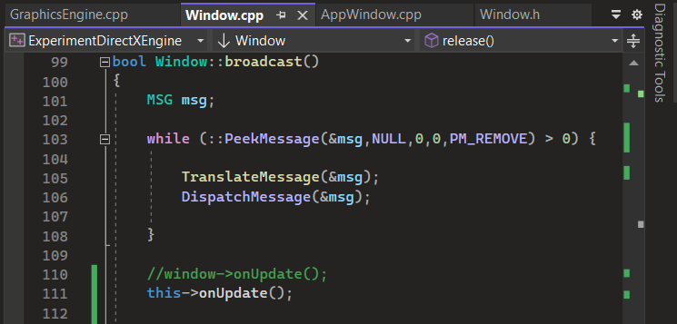

24)

